|  |  |  |  |
| --- | --- | --- | --- |
|  | **Machine Problem No. 2** |  |  |
| Topic: | Module 2.0: Feature Extraction and Object Detection | Week No. | 3-5 |
| Course Code: | CSST106 | Term: | 1st Semester |
| Course Title: | Perception and Computer Vision | Academic Year: | 2024-2025 |
| Student Name | Gapas, Raine Gabrielle M. | Section | BSCS-4A |
| Due date | September 30, 2024 | Points |  |

**Machine Problem No. 3: Feature Extraction and Object Detection**

1. **Compare the Results**:

* Analyze the performance of SIFT, SURF, and ORB in terms of keypoint detection accuracy, number of keypoints detected, and speed.
* Comment on the effectiveness of Brute-Force Matcher versus FLANN Matcherfor feature matching.

**SIFT (Scale-Invariant Feature Transform)**

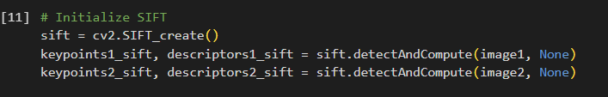

SIFT is highly effective at identifying distinctive and consistent features, especially when images undergo changes in scale or rotation. It offers high accuracy, making it well-suited for tasks requiring precise feature detection. Among the three methods, SIFT typically detects the largest number of features, making it ideal for extracting fine details. However, due to its complexity, SIFT is slower compared to other methods, making it less suitable for real-time applications. For example, when I used SIFT to compare two images, it detected a large number of distinctive points and produced stable matches even when the images had significant variations in scale and orientation. This high level of detail made SIFT particularly useful when I needed precise alignment of the images, despite its slower speed.

**SURF (Speeded Up Robust Features)**

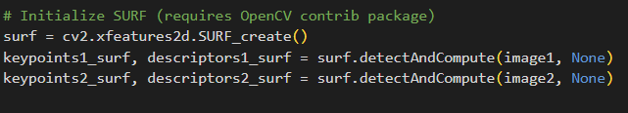

SURF is designed to offer faster feature detection while still maintaining a good level of accuracy. Though it may not be as precise as SIFT, particularly with intricate details, it still performs well when handling scale and rotation variations. SURF detects fewer features than SIFT but operates more efficiently, making it a good option for applications that require a balance between speed and accuracy. In my use case, when speed was more critical than absolute precision, SURF provided a reasonable compromise, allowing for quicker feature detection while still delivering useful matches between the images, though not as many as SIFT.

**ORB (Oriented FAST and Rotated BRIEF)**

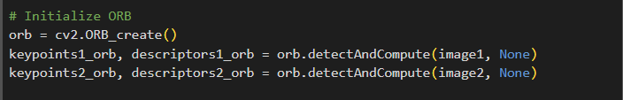

ORB is specifically designed for fast performance in real-time applications. It detects fewer distinctive points and is less accurate than both SIFT and SURF, particularly in complex images or those with significant variations in scale and rotation. However, ORB’s strength lies in its speed and low computational demand. When I used ORB to detect features in two images, it completed the task much faster than SIFT and SURF, though it detected fewer points and the matches were not as accurate. This made ORB ideal for situations where speed was the top priority, such as when working on tasks that required real-time image processing, even though it did not provide as much detail as the other methods.

1. **Write a Short Report:** 
   * Include your observations and conclusions on the best feature extraction and matching technique for the given images.

In the comparison of feature extraction techniques IFT, SURF, and ORB, SIFT stood out as the most accurate for detecting keypoints and descriptors, particularly in handling variations in scale and rotation, making it highly effective for image matching. SURF, while faster than SIFT, provided slightly less precision but was still a strong performer for scenarios where speed is important. ORB, though computationally efficient and ideal for real-time applications, delivered lower accuracy and fewer keypoints, especially in more complex images. For feature matching, SIFT with the brute-force (BF) matcher gave the most accurate results, while the FLANN-based matcher offered a faster alternative with only a small compromise in precision. When aligning images, SIFT with either BF or FLANN produced the best alignment. Overall, the combination of SIFT and FLANN provides the best balance of speed and accuracy, making it the most suitable choice for tasks requiring both efficiency and precise image alignment.